**Assignment No 5**

* Exercise Question Conditional Formatting

**1. Apply conditional formatting to highlight cells in the Sales column (D) with values greater than or equal to 150.**

**Ans:**

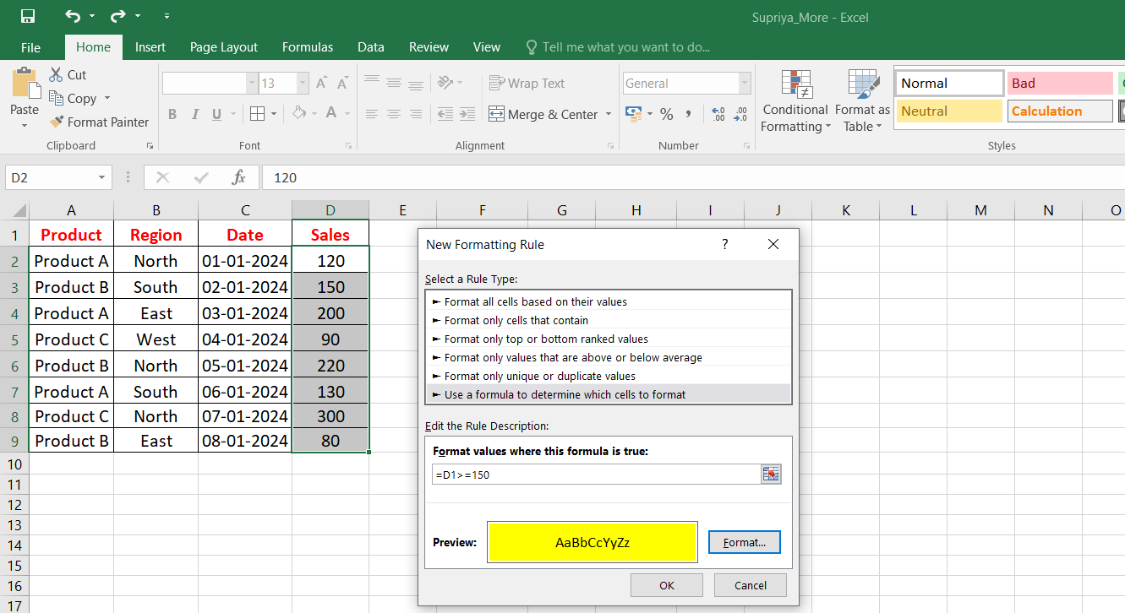

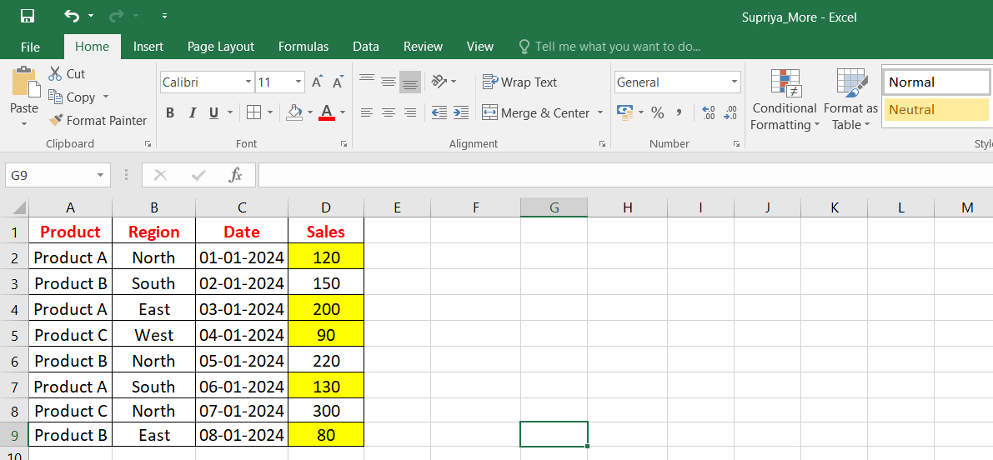

**2. Apply conditional formatting to highlight the entire row for entries where the Product is "Product A".**

**Ans:**

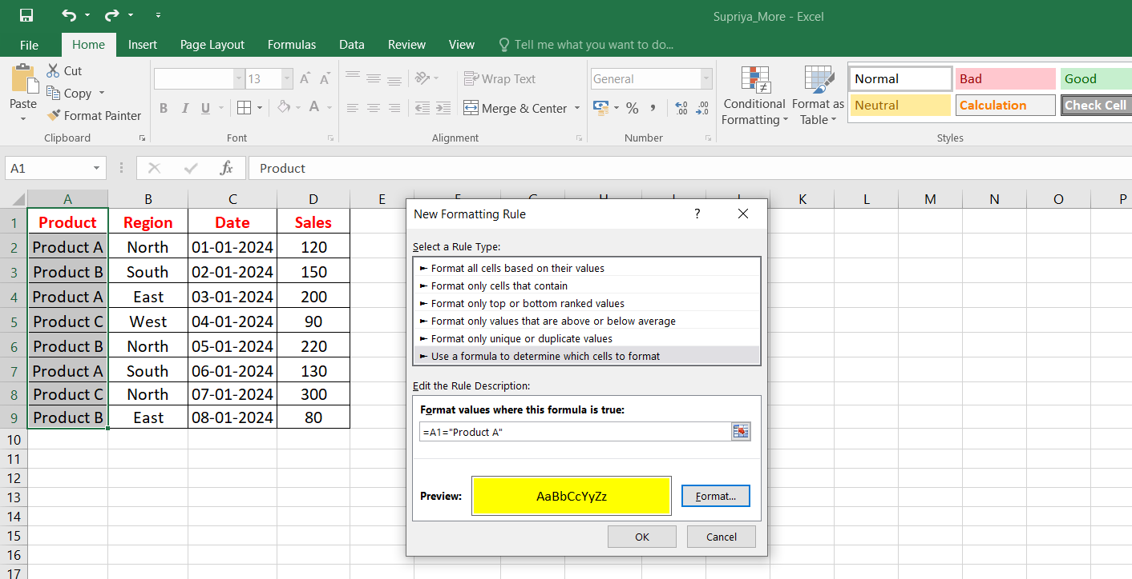

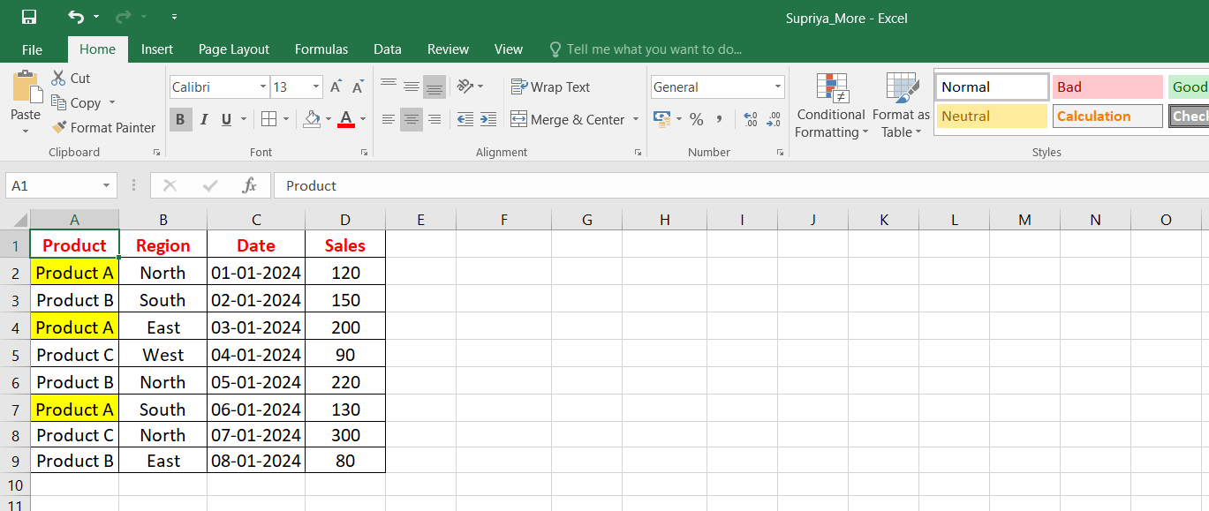

**3. Apply conditional formatting to highlight cells in the Date column (C) that fall within January 2024.**

**Ans:**

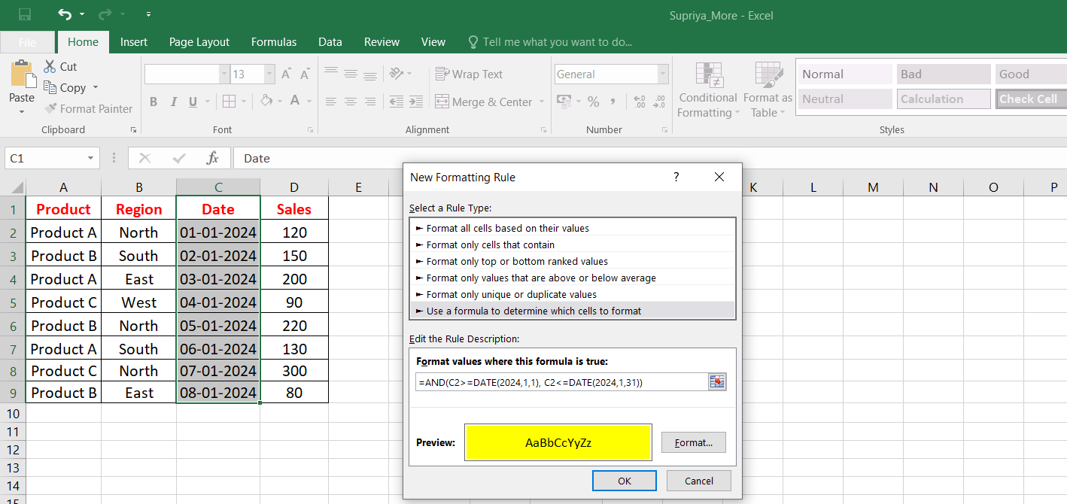

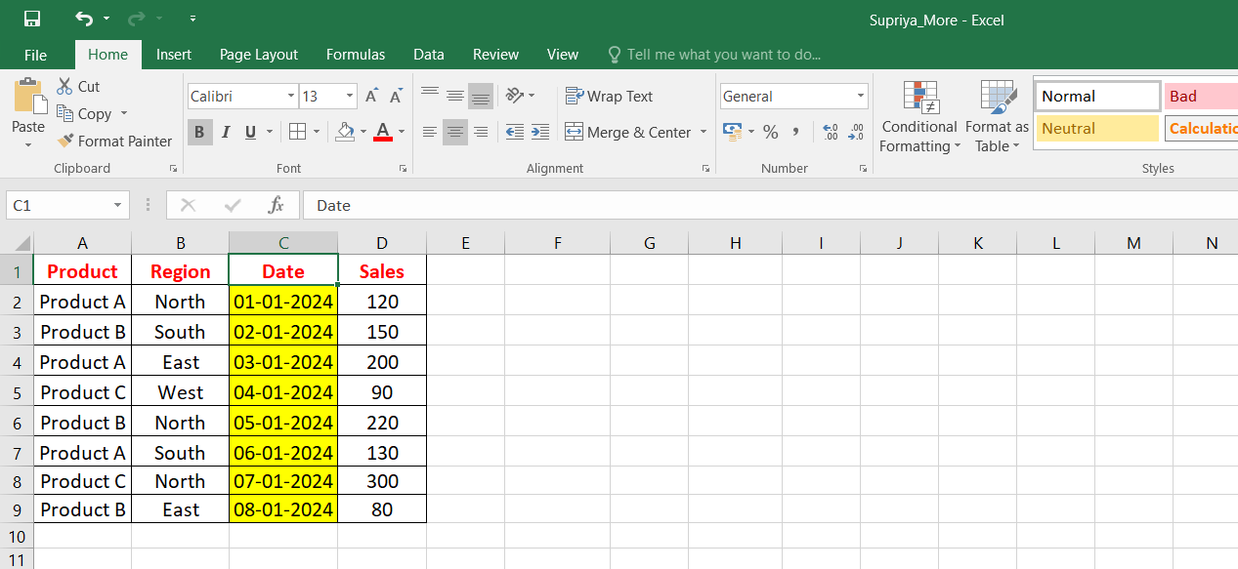

**4. Apply conditional formatting to highlight the top 3 sales values in the Sales column (D).**

**Ans:**

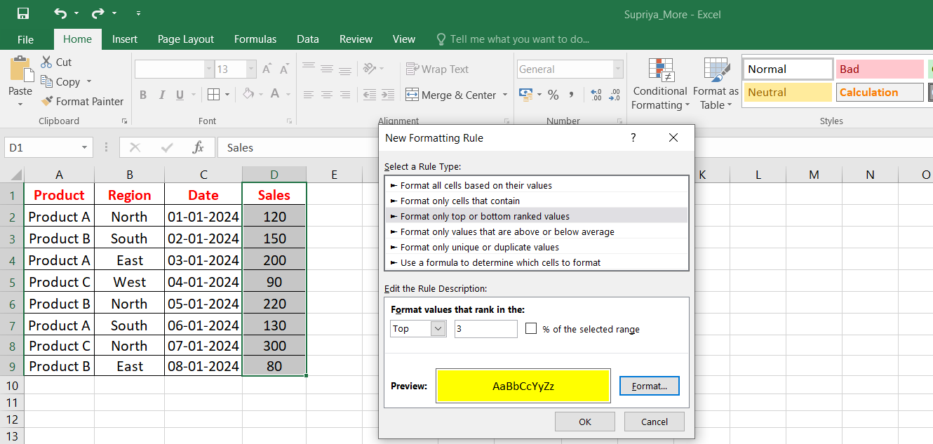

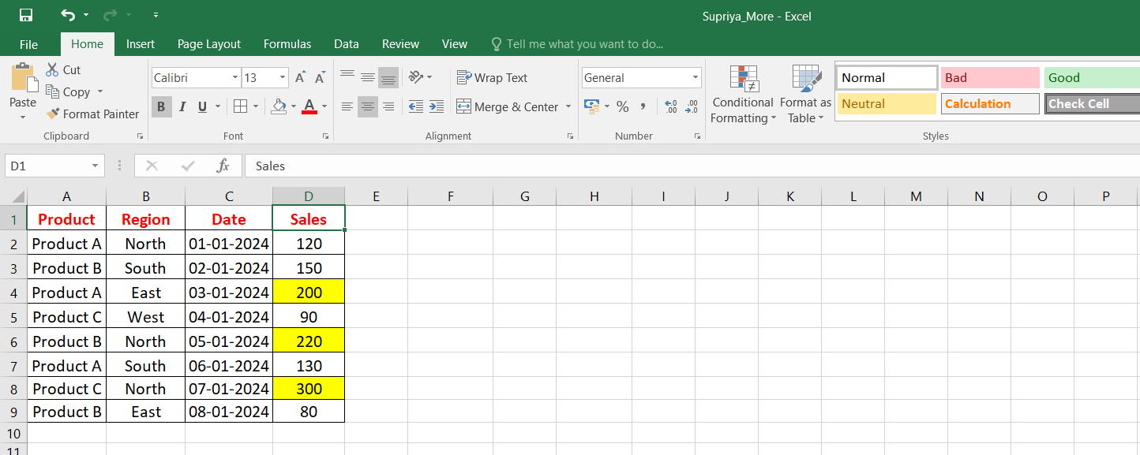

**5. Apply conditional formatting to highlight sales for "Product B" in the "North" region.**

**Ans:**

